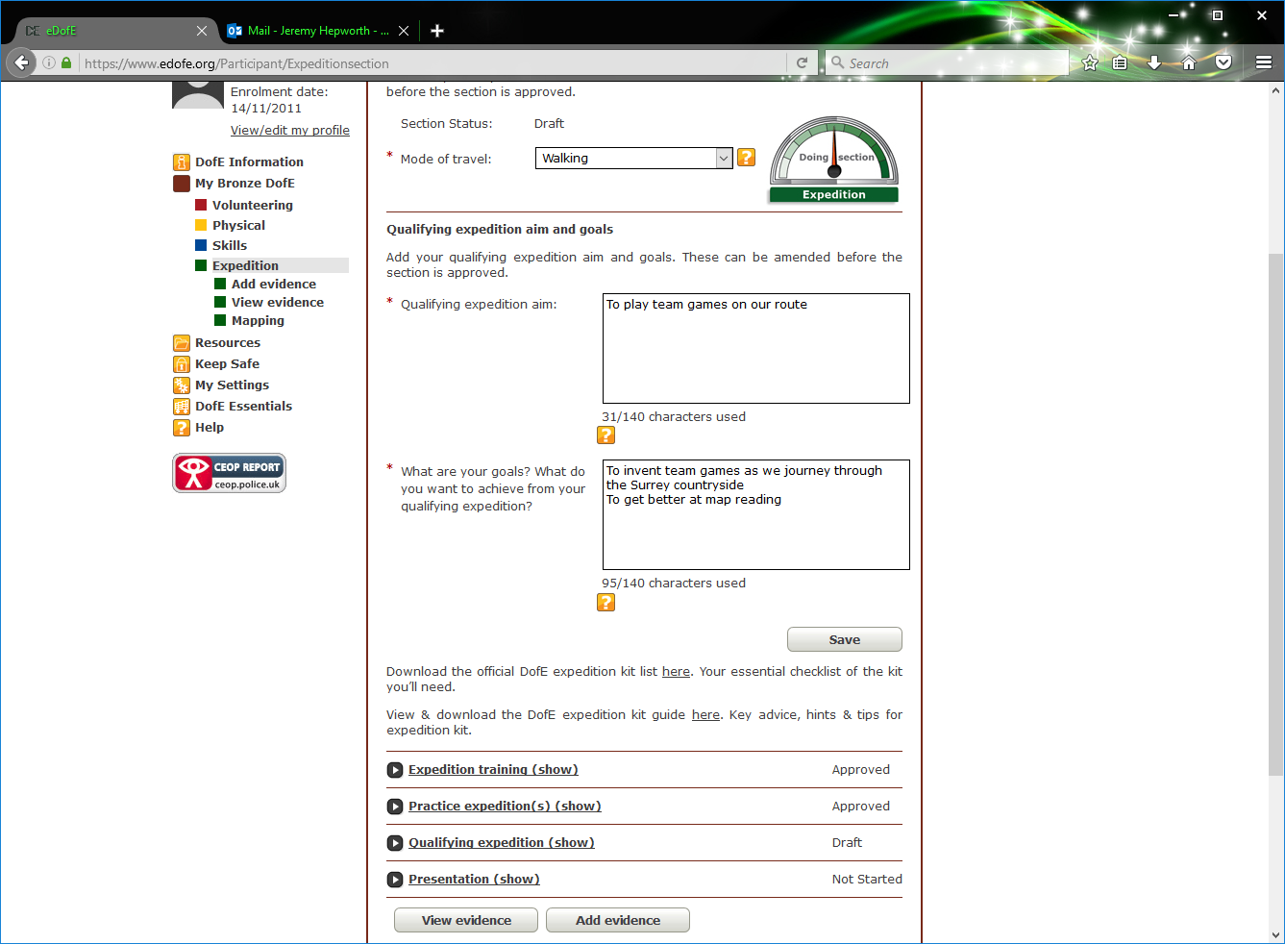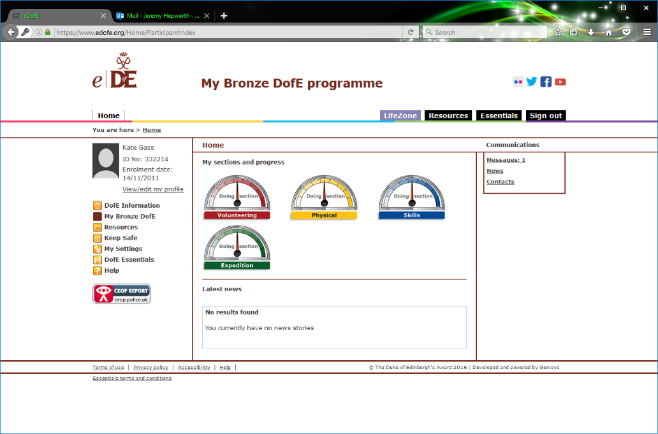

**Completing the Expedition section**

You need to make sure you have submitted for approval your qualifying expedition

When the indicator is at the top it means you have started the section but it is not completed

You should enter your qualifying expedition aims and objectives here

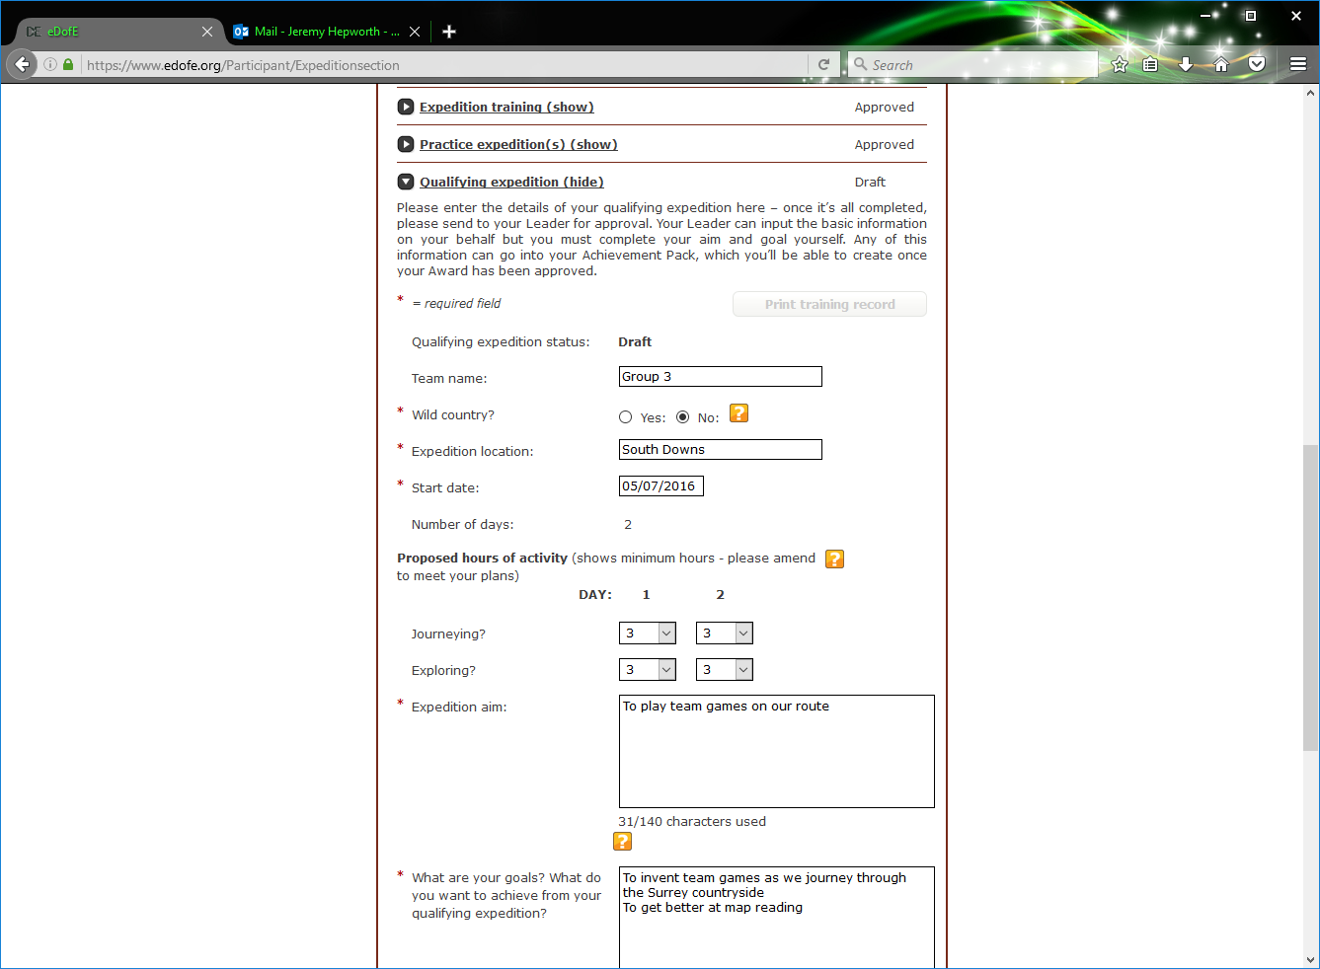

Then click here

Wild Country = NO

You may need to alter these if your plans were diffferent

Enter the where the expedition took place and the start date

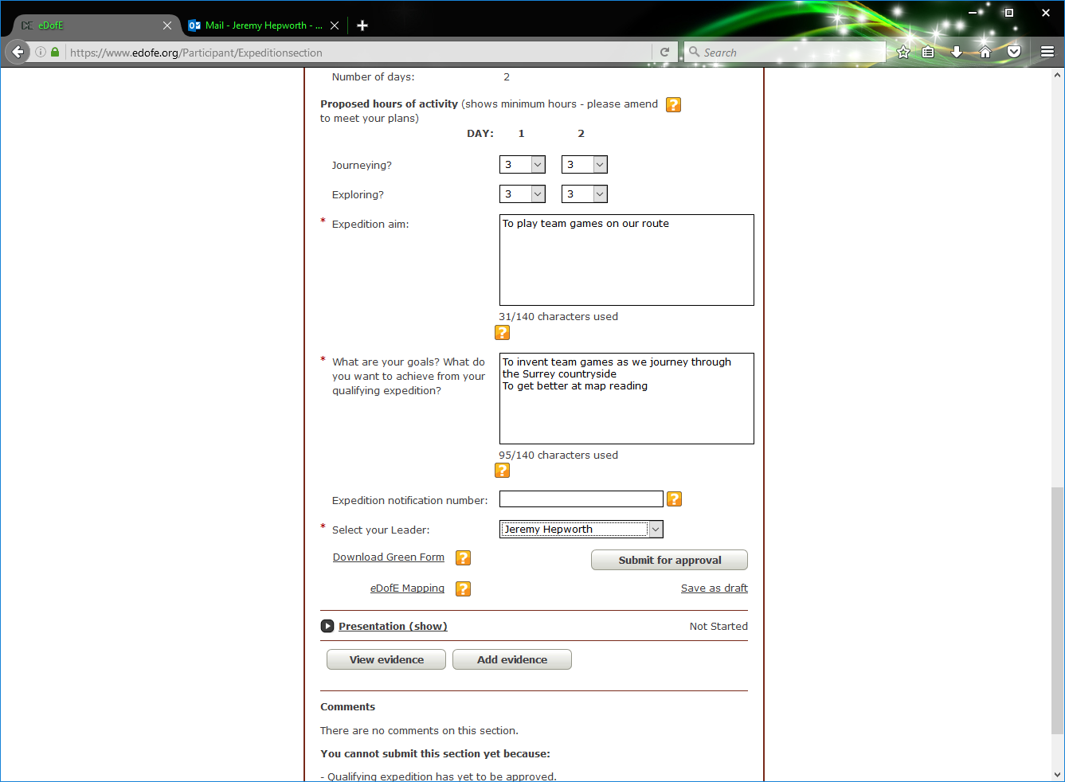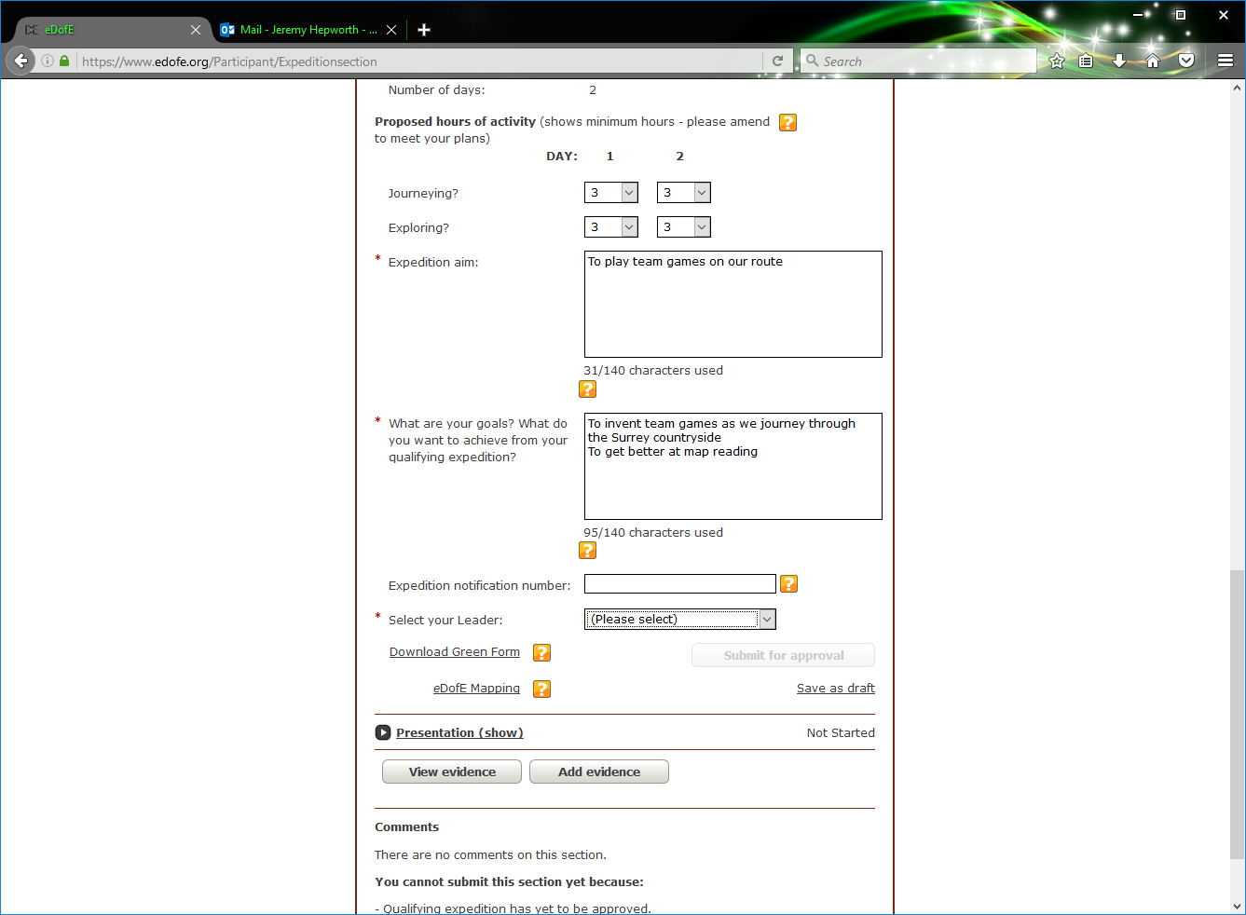

Select someone from this list   
(it doesn’t really matter who)

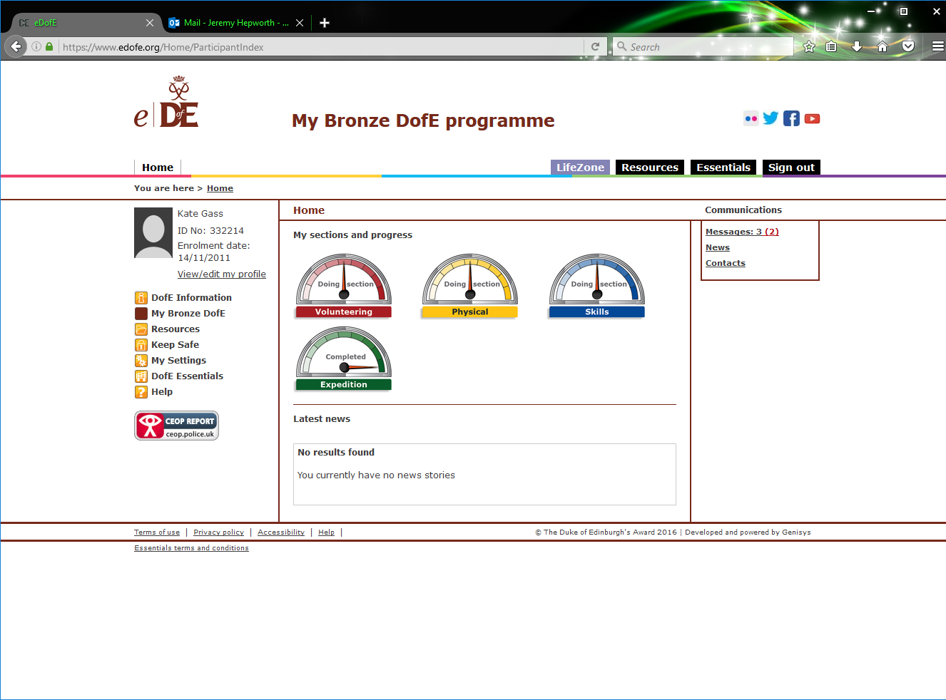

Then click here to submit for approval

**Now your expedition section is completed Well done!**